How to Read TODO: Comments

1. When your program is graded, I will make comments if there is an issue. I will also make comments if you did something well. Finally, your grade will be posted just above main() in a comment.
2. These comments can be hard to fine, especially when your programs get more complex. To make them easier to access, we will use TODO: Comments.
3. TODO: Comments are actually that. You can use them to remind yourself TO DO something in your code. But we use them for feedback.
4. Here is the part of the code from a typical program. I have made some TODO: comments.

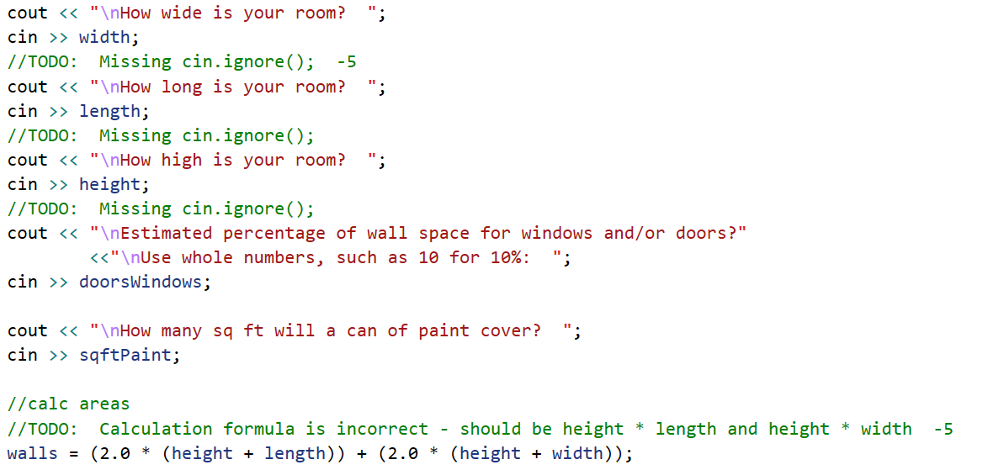

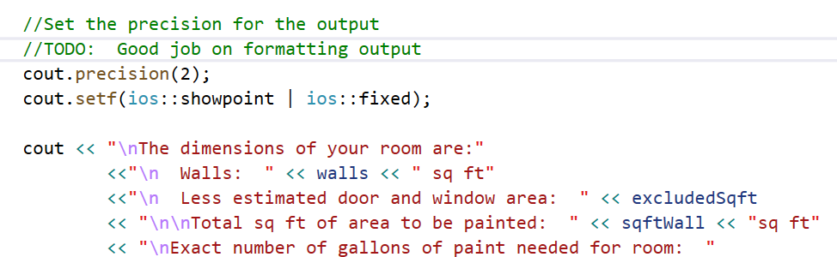

1. How do you get these comments? TODO: Comments come through the Task List. Go to View > and select Task list:

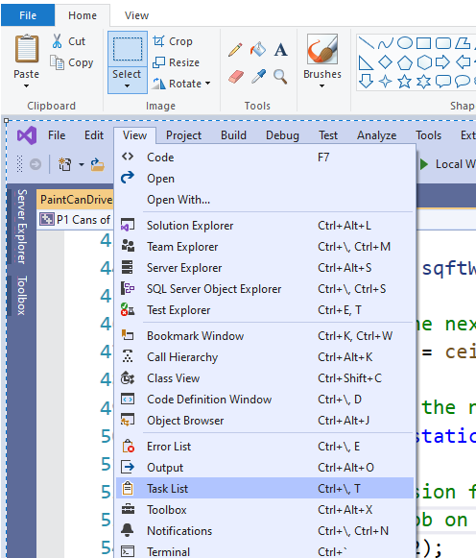

1. The task List is shown in a tab at the bottom of the Visual Studio editor, like the Output Window. Here is what you would see for the example code.

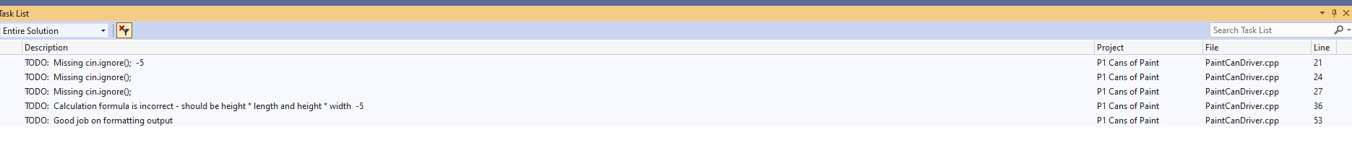

1. Notice that all the TODO’s are listed and at the right, their line numbers are identified. As a short cut, just double-click on the line you want to see and Visual Studio will take you there.